Cover
Use the same design from the trifold (Add “Onsite Program”)

Can you incorporate/Display the following CSHA’s”

Mission Statement:
Empowering our community through education and advocacy by cultivating connections, promoting excellence, and providing equitable access to person-centered, culturally responsive services.

Vision Statement:
Making Colorado a place where all voices are heard.

Page 2 Welcome Message (Full Page)
Emily wants it to look like her designed layout
Content and layout: WelcomeLetter.docx

Page 3 Tracker
Tracker-CO2024.xlsx
You may want to landscape this as you did in the program mailer since we have to include the sponsor logos, the presenters, room and CE value.

Just a thought. If fitting the logos into the grid is not working, maybe we could just list the sponsor (and logos) off to the side?

Logos for the grid Logos
- MGA Logo (EI Track)
- AnthroMed Education (Education Track)
- Gelmix + Purathick (Luncheon)
- Amazing (Happy Hour)
- Abby Care (Happy Hour)
- Stepping Stones (Knowledge Quest)

Page 4 Partners and Exhibitors
All logos can be found here: S:\CSHA\Conferences-CSHA\Fall-CSHA\2024-Fall-CO-Parker\Exhibits-CO-2024\Logos-CSHA2024

Partners
Display logo and list sponsorship below.
- MGA Homecare EI Track
- AnthroMed Education Education Track
- Gelmix + Purathick Lunch
- Front Range Pediatric Therapies Breakfast
- Amazing Care Home Health Services Happy Hour
- Care Options for Kids Breakfast
- Aveanna Healthcare, LLC Breakfast
- Abby Care Happy Hour
- Summit Speech Therapy Lanyards and Badges

Exhibitor Logos to display (30)
Boho Speechie
Ms. Dawn SLP
Layers Consulting
Gillem Staffing
Summit Speech Therapy
MGA Homecare
Forbes AAC
Simply Thick
Handprints Therapies
Kids Care Home Health
Douglas County School District
PRC - Saltillo
The Stepping Stone Group
Front Range Pediatric Therapies
Amazing Care Home Health Services
Bjorem Speech Publications
Discovery toys
Pediatric Development Services
Care Options for Kids
Hunter's Hope Soaps
Numotion Speech Solutions
Aveanna Healthcare, LLC
Woven Care
Abby Care
Craig Hospital
Square Peg Therapies
Denver Public Schools
Gelmix + Purathick
AnthroMed Education
Ampersand Therapy

Ad Pages:
Received ad can be found here: Ads
Save Space For
Woven Care – Half Page
Care Options - Full Page Gelmix – Half Page
Ampersand – Half Page AnthroMed Ed – Full Page

Back Cover – Map and CE Info
They are returning to the same place as in 2022. Your onsite program file should have this map but it needs some Edits

- Orange Block
- Remove the “200”
- Below Session Room, add “ Friday Lunch”
- Green Block
-Add below Silent Auction “Exhibits”
- Gold “CW” remove “65”
- Gold “CE” remove “65”
- Burnt orange “remove CSHA Lunch Fri”
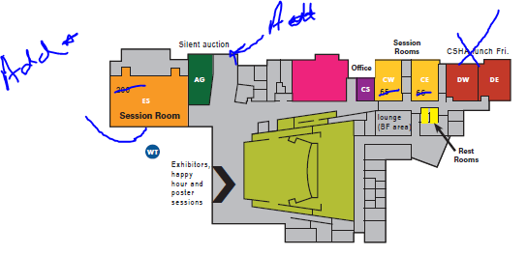

Continuing Education:
The DEI session (S22) is offered separately for 0.2 ASHA CEUs (introductory level).
Presenter disclosure available at cshassoc.org.


