KSHA Program Mailer Content

PAGE 2 (Will have the letter + DEI Info + Supv Info + Ethics Info
Co-Directors “Join Us” Letter

Innovation: A word that carries the power to transform, revolutionize, and inspire. But it's not just a word—it's a promise for growth and fresh possibilities. We are thrilled to invite you to embrace innovation at the 2024 Kentucky Speech-Language-Hearing Association Convention, where we will come together to explore Innovation@Work.
The 2024 convention will fuel your enthusiasm, enhance your skills, and equip you with the latest tools and strategies to excel in your field. Our theme, Innovation@Work, embodies the evolving fields of speech-language pathology and audiology. We understand that staying current in your practice is not just a choice—it's essential.
But the KSHA Convention is more than just a learning opportunity. It's a chance to connect with like-minded professionals who share your dedication and drive. As you consider joining us in Lexington, picture yourself engaging in thought-provoking discussions, exploring new techniques and renewing your passion for your profession. Your presence at the convention is not just an investment in yourself—it's a commitment to the future of speech-language pathology and audiology in Kentucky.
Registration for the 2024 KSHA Convention is now open, and we urge you to secure your spot today. Together, let's welcome innovation, celebrate progress and shape the future of our field. We eagerly anticipate seeing you at a convention experience that will leave you inspired, motivated and ready to make a difference.
Innovation awaits. See you in Lexington!

Photos
Kayla Redden
Katie McComas Maddy
Photo: Photo-Redden.jpg Photo: maddy headshot.png

Special Session Offerings ( All of this goes under the Join Us letter where the Ethics panel was listed)
Each year, KSHA invites presenters to specifically help you meet Licensure and ASHA special continuing education requirements. We are pleased to announce our invited DEI, Supervision and Ethics Invited Presenters:

DEI
Wednesday 12:00 pm - 2:00pm
Embodying a New Lens: An Approach to Culturally Responsive Practice (S07)
Lauren Prather, MS, CCC-SLP
Photo: S:\KSHA\Convention - KSHA\Convention-2024-Lexington\Speakers-2024-KY\Photos-KY-2024\Prather.png

This session aims to discuss a culturally responsive application and how to lay the foundation for non-discriminant practice in assessment and intervention.

Supervision
Wednesday 12:00 pm – 2:00pm
Clinical Supervision: Using Effective Communication, Providing Feedback and Setting Expectations (S05)
Donna Morris, MA,CCC-SLP and Aimee Sayre, MA, CCC-SLP
Photos:S:\KSHA\Convention - KSHA\Convention-2024-Lexington\Speakers-2024-KY\Photos-KY-2024\morris.jpg
S:\KSHA\Convention - KSHA\Convention-2024-Lexington\Speakers-2024-KY\Photos-KY-2024\Sayer.jpg

This session will discuss principles for effective teaching of clinical skills, including how to set expectations when working with supervisees.

Page 2 Continued
ETHICS (Replace Information)
Wednesday 3:30 pm – 5:30 pm
Ethics Across Settings: A Panel Discussion (S11),

Alison Brown EdD, CCC-SLP
Photo: S:\KSHA\Convention - KSHA\Convention-2024-Lexington\Speakers-2024-KY\Photos-KY-2024\Brown,Alison.jpg
Nikki Gaylord EdD, CCC-SLP
Photo: S:\KSHA\Convention - KSHA\Convention-2024-Lexington\Speakers-2024-KY\Photos-KY-2024\Gaylord.jpg
Stephanie Schaaf EdD, CCC-SLP
Photo:S:\KSHA\Convention - KSHA\Convention-2024-Lexington\Speakers-2024-KY\Photos-KY-2024\Schaaf.jpg
During this presentation, participants will examine the Code of Ethics through a panel discussion in the context of ethical dilemmas taken from clinical case studies across medical, school, and early intervention settings.

Note. Review thee Session Tracker for other qualifying sessions.
Category | ASHA 3 Year Interval Certification: 30 PDHS | Licensure Biennial Period
DEI | 2 hours of the required thirty (30) required PDHs | Not required at this time.
Ethics | 1 hour of the required thirty (30) required PDHs | 2 hours of the required thirty (30) continuing education hours and 2 hours of the required fifty (50) hours for those holding dual licenses.
Supervision/Clinical Instruction | One time requirement for those in a student/CF supervisory position, earn at least two hours post-certification | Not Required at this time.

Page 3
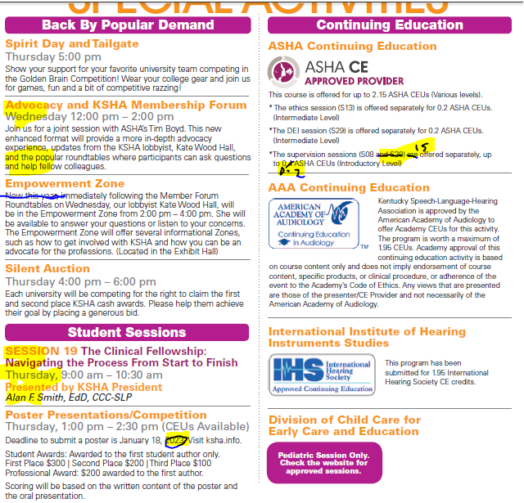

Remove Entire Section

S21 Navigating The Path To CCC
Thursday, 11:00 am – 12:30 pm
Presented by KSHA President
Robyn Wahl, MS, CCC-SLP
S34 Passing the PRAXIS-ONE TIME ONLY!
Thursday 3:00 pm – 4:30 pm
Presented by LaToya Roberts, MS, CCC-SLP

Change Year to 2024

KEYNOTE (Replace Information)
Photo S:\KSHA\Convention - KSHA\Convention-2024-Lexington\Speakers-2024-KY\Photos-KY-2024\Katte.jpg
Wednesday 2:15 pm – 3:15 pm
Joel Katte, Presents
Presenting, Igniting Passion and Purpose With The Be More You Experience! (S09), on Wednesday.

Joel Katte's The Be More You Experience was adapted from his children's book (written for all ages including adults) Finding You At the Zoo. Imagine if throughout your life you and everyone around you received the message … Just keep being you; in fact, be even more you! Through humor, inspiration and discussion, Joel will guide participants on a journey of self-reflection, discovery and affirmation that will catapult them forward to live the lives they know deep down they were destined to live.

LUNCHEON (Replace Information)
Photo:S:\KSHA\Convention - KSHA\Convention-2024-Lexington\Speakers-2024-KY\Photos-KY-2024\Hammond.jpg
Friday 12:30 pm -1:30 pm
Tiffany Hammond
Presenting, Anatomy of A Day with No Words (S57)
This personal story highlights the bond between mother and child and follows them on a day where they use a tablet to communicate with others, breaks down the inside of these days and how they came to be.

Pages 4-5 Highlighted Presenters
Content: Highlighted Presenters.docx
Photos: S:\KSHA\Convention - KSHA\Convention-2024-Lexington\Speakers-2024-KY\Photos-KY-2024

Pages 6-7 Session Tracker
TrackerKY2024.xlsx

Back Cover

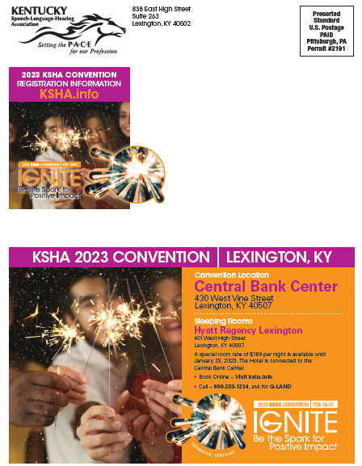

Change Year to 2024:

A special room rate of $171 per night is available until January 22, 2024. The Hotel is connected to the Central Bank Center.
- Book Online - Visit ksha.info
- Call – 800 283-1234, Mention Block Code G-HEAQ

Change Year to 2024
Incorporate Logo

