CSHA 2025 ONSITE Digital Booklet
Cover
- Use the same design from the trifold (Add “Onsite Program”)
- incorporate/display the following CSHA’s Mission and Vision Statement

Mission Statement:
Empowering our community through education and advocacy by cultivating connections, promoting excellence, and providing equitable access to person-centered, culturally responsive services.

Vision Statement:
Making Colorado a place where all voices are heard.

Page 2 Welcome Message (Full Page)
Same layout as last year – Just revise the content in each area
Content: WelcomePageContent.docx

Page 3 Tracker 2025
You may want to landscape this as you did in the program mailer since we have to include the sponsor logos, the presenters, room and CE value.

- No gray sections or gold.
- Adding a Color to each room name to coordinate with the map
- Let’s try using Colorful Box Outlines to highlight an event (see my document)
S:\CSHA\Conferences-CSHA\Fall-CSHA\2025-Fall-CO-Parker\OnsiteProgram-Digital2025\Tracker-OnsiteBooklet.xlsx

Page 4 – Move Map + CE Info (if room) to this page. Want this near the tracker please
They are returning to the same place but the map needs re-labeled with full room names (ES is now Event center, CW is now Creative Studio West, etc. (
Room colors must match the colors you used in the Tracker.

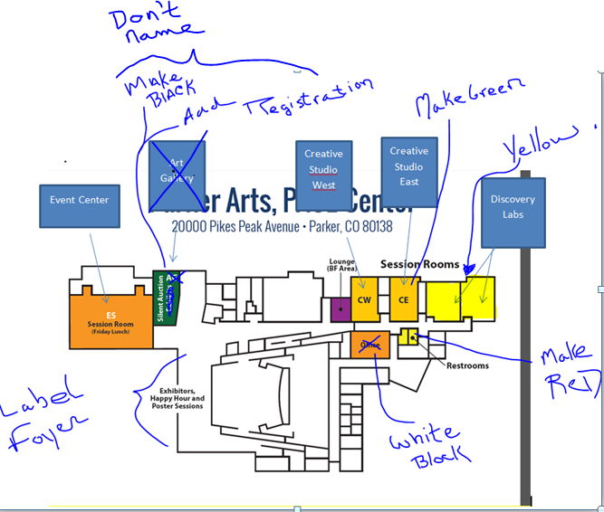

S:\CEU\BrandBlocks-ASHA\Brandblocks-ASHA-CO\completed-brandblocks\CSLH Brand Block - 2025Fall.pdf (copy from tri-fold)

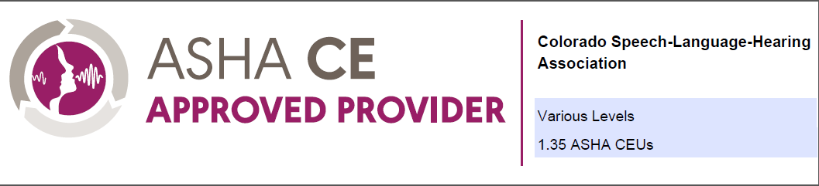
DEI sessions (S08 and S12) are offered separately for up to 0.3 ASHA CEUS (Intermediate level).
The Ethics session (S29) is offered separately for 0.1 ASHA CEUS (Introductory Level).
Presenter disclosure available at cshassoc.org.

Page 5 Partners and Exhibitors
Sponsors at the top. Highlight in some way to make standout. All other logos would go below. Block format like your website page (neat and tidy, please).
All logos: S:\CSHA\Conferences-CSHA\Fall-CSHA\2025-Fall-CO-Parker\Exhibits2025\LogosEXH-CSHA2025
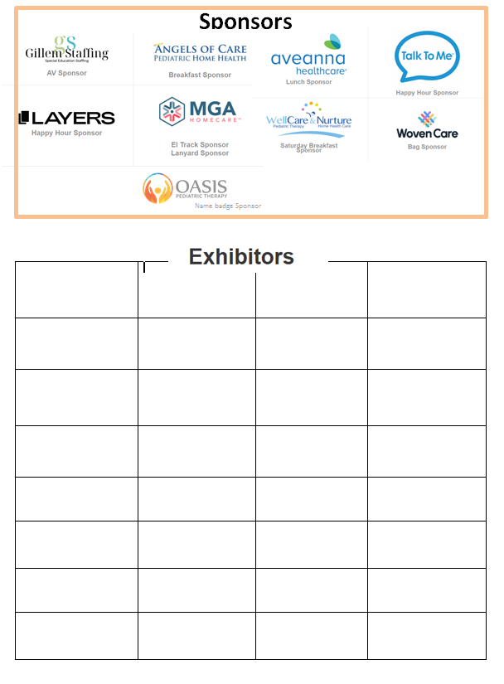
Beyond Therapy

Ad Pages: At this moment I am just missing one Qtr Page (Beyond Therapy) RECEIVED 9/5
Ads can be found here:S:\CSHA\Conferences-CSHA\Fall-CSHA\2025-Fall-CO-Parker\OnsiteProgram-Digital2025\Ads-2025

