COVER
Use the Cover From the Mailer -
- Add: “ Onsite Booklet”
- Add Room Location for the Keynote: Hall of Champions 1
- Remove the Highlighted Speaker Listing and title
- Add Stacked to left of Keynote: Silent auction, the Pathfinder and handout link
- Add Wifi: Open Network Password: 2254

Silent Auction
Benefits Scholarships
Bidding Times
Starts 1:00 pm Wednesday
Ends 1:00 pm Friday
Pick-up Until 3 pm

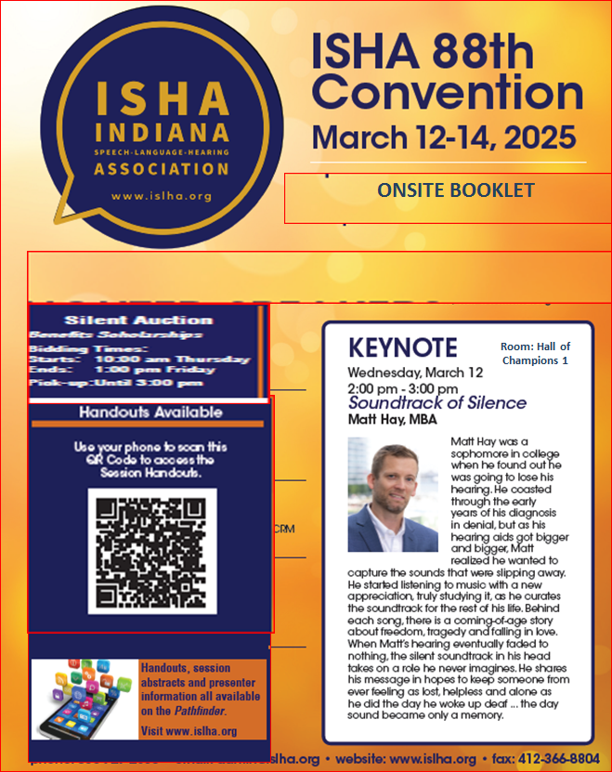

PAGE2
Welcome!
President’s Message
On behalf of the entire ISHA Executive Council, I am delighted to extend a warm and enthusiastic welcome to the 88th Annual ISHA Convention! We are thrilled to have you with us. Whether you are a first-time attendee or a returning participant, we hope your experience here will inspire new ideas, foster valuable connections and provide you with tools and insights to apply to both your professional and personal endeavors.
In between sessions, be sure to check out our exhibit hall and visit our silent auction, where you can help raise funds for student scholarships. On Friday, don't miss our annual business meeting and awards ceremony.
Our Vice Presidents of Professional Development Paige Blocker, Whitney Beltre’ and Laura Bobinsky, along with our Vice Presidents of Audiology Jen Bidelman, Chelsea Byard, and Julie Jones, in collaboration with Craven Management Associates, have worked diligently to curate an engaging agenda. A huge thank you to all of our speakers, sponsors and volunteers. Without your support and dedication, this event would not be possible.
Marianne Samuel, MA, CCC-SLP
S:\ISHA\Convention-ISHA\Conv2025-ISHA-WyndhamIndianapolis\OnsiteProgram-ISHA2025\Photo-President.jpg

New for 2025 - a 2nd welcome message

Vice President of Professional Development
Welcome to the 2025 ISHA Convention! We’re thrilled you’ve chosen to join us this year!

The Convention is an opportunity to learn from experts in our fields and connect with friends and colleagues from across the state to share knowledge and experiences, advance our professions and be inspired.

Your convention committee has crafted a program that represents topics across practice settings and considers the needs and perspectives of the diverse populations we serve. Course offering allow attendees to cultivate a learning experience that encompasses a variety of topics and provides the opportunity to participate in several sessions that can be combined to dive deeper into a particular topic (e.g., the science of reading, adult dysphagia, pediatric feeding disorders).

This year, we are also honored to hear from Matt Hay as he shares his lived experiences in a keynote address and Dr. Scott Palasik with the screening and discussion of his documentary When I Stutter.
We are grateful for your support of ISHA and dedication to life-long learning and our professions. We look forward to your feedback to help us continue to develop programming that supports your professional growth and inspires you for years to come.

Laura Bobinsky Photo: Bobinsky-New.jpg
Whitney Beltre Photo Whitney-NewPhoto.jpg
Paige Blocker Photo brown-Paige-125w.jpg

ISHA At A Glance (replace all)
Wifi: Open Network Password is 2254

WEDNESDAY
1:00 pm–6:30 pm .................. Registration
1:00 pm–5:30 pm .................. Exhibits Open
2:00 pm–6:30 pm ................... Sessions

THURSDAY
7:00 am-4:30 pm .................Registration
7::00 am-3:00 pm .................Exhibits Open
7:00 am-8:00 am ..................Breakfast in Exhibit Hall
8:00 am–4:30 pm ................Sessions
11:00 am -12:00 pm………… Demonstrations - Group 1
1:00 pm-2:00 pm ……………. Demonstrations --Group 2

Friday
7:30 am–4:45 pm ................Registration
8:00 am–9:30 am ................ Breakfast: Annual Meeting
and Awards Ceremony (Ticket Required)
9:00 am-1:00 pm ………………..Exhibits Open
9:45 am-4:45 pm ………………..Session

Page 3 Exhibitors and Sponsors.
Add New Header: Meet the Sponsors & Exhibitors
Wednesday 1:00 pm–5:30 pm | Thursday 7:00 am – 3:00 pm | Friday 9:00 am – 1:00 pm
Refreshments will be available in the Exhibit Hall during break.
Grab some coffee and visit an Exhibitor!

Highlight these Vendors:
Associates in Ped Therapy - Premiere Sponsor
PRC – Premiere Exhibitor and Lanyard Sponsor
K1ds Count Therapy – Premiere Exhibitor and Bag Sponsor
IEP Therapy – Premiere Exhibitor
Exhibit Logos to display: S:\ISHA\Convention-ISHA\Conv2025-ISHA-WyndhamIndianapolis\Exhibitors-IN2025\Logos-ISHA2025

Pages 4 – 5 Session Tracker (Put The ASHA Brand Block and Language from Mailer below Tracker)
ST 2.xlsx

Page 6 – Demonstrations (we don’t have to list the list description I included if spacing is an issue.
Just need to clearly show two separate groups/times.
Posters-Onsite.doc

Ads – Missing some but this is digital so we can drop in when received.
Ads-ISHA2025

Back Cover
Map: Event space map.png

