KSHA Program Mailer Content - 2026

PAGE 2
Co-Directors “Join Us” Letter

Experience The Essence of Communication at the 2026 Kentucky Speech-Language-Hearing Association Convention!

Communication is at the heart of human connection. It is the thread that empowers minds, shapes relationships and transforms lives. As professionals in speech-language pathology and audiology, we know that the ability to communicate effectively is essential for learning, connection and personal growth. We invite you to join us in celebrating and deepening our understanding of The Essence of Communication, Empowering Minds, Transforming Lives at the 2026 Kentucky Speech-Language-Hearing Association Convention, February 18–20, in Lexington, Kentucky.

Together, we will explore innovative approaches, evidence-based practices and inspiring stories that highlight the transformative power of communication in all its forms. This year’s Convention will offer opportunities to learn from expert presenters, engage with emerging technologies and develop creative solutions to the challenges we face in our work. It will also be a place to share successes, network with colleagues, and discover new strategies to empower those we serve.

Don’t miss the opportunity to be part of this vibrant, passionate community working to advance the fields of speech-language pathology and audiology. Together let’s harness The Essence of Communication to Empower Minds and Transform Lives.

Your Chairs,
Chelsea Graham and Brittany McAndrew

Photos:
Chelsea
S:\KSHA\Convention - KSHA\2026-Lex-Feb18-20\ProgramMailer-KSHA-2026\Graham-160w.jpg
Brittany
S:\KSHA\Convention - KSHA\2026-Lex-Feb18-20\ProgramMailer-KSHA-2026\Photo-brittany-mcandrew-140x181-1.jpg

Page 2 - Special Session Offerings (replace info from last year)

Note: Sydney Bassard is both the DEI and Ethics Presenter. Thinking Both (DEI/Ethics listing) should be side by side so you only have to list her photo/name once.

DEI
Wednesday 12:00 pm - 2:00pm
Five Practical Steps to Foster Family Participation (S07)
Sydney Bassard, MSP, CCC-SLP
Photo: S:\KSHA\Convention - KSHA\2026-Lex-Feb18-20\Speakers-KSHA2026\Photos-KSHA2026\Bassard.jpg

This session will cover five strategies to increase family participation by understanding how their culture influences care decisions, learning how to examine your own cultural humility and providing recommendations and treatment that align with their family values and belief systems

ETHICS
Wednesday 3:30 pm – 5:30 pm
Exploring the World of Social Media Through an Ethical Lens (S11)
Sydney Bassard, MSP, CCC-SLP
Photo: S:\KSHA\Convention - KSHA\2026-Lex-Feb18-20\Speakers-KSHA2026\Photos-KSHA2026\Bassard.jpg

Each year, more and more professionals (SLPs and AuDs) go to social media to find community and learn how to become better at their jobs. Social media is here to stay for the time being, but professionals need to be smart consumers of information and resources presented to them.

Sydney will also be presenting Navigating the Path of Alphabet Learning Through Speech Sound Integration (S16) on Thursday.

Supervision
Wednesday 12:00 pm – 2:00pm
Building Competence and Confidence: Supervision in Speech-Language Pathology and Audiology (S06)
Erin Pittard, MS, CCC-SLP
Tammy Pierce, MA, CCC-SLP
Photos:
S:\KSHA\Convention - KSHA\2026-Lex-Feb18-20\Speakers-KSHA2026\Photos-KSHA2026\Pittard.png
S:\KSHA\Convention - KSHA\2026-Lex-Feb18-20\Speakers-KSHA2026\Photos-KSHA2026\Pierce.png
This session is designed to build the capacity and confidence of speech-language pathologists and audiologist in supervisory roles across clinical and educational settings. Participants will explore strategies to effectively train and mentor graduate students during practicum placements and extend their support into the clinical fellowship year

Page 3

See pdf for changes
P3-Edits.pdf
Anne Blandford’s photo:Blandford Anne '24_p 4x6-NEW2024.jpg
Replacement Content for Box at the bottom:
New This Year - The RISE Committee: Meet and Greet
Thursday, February 19 | 8:00 am – 9:00 am

The RISE Committee (Respect, Inclusion, Support and Equity, formerly DEI) invites you to join them
for an opportunity to network by meeting others and sharing experiences. Coffee and light bites will be available in the room or grab your breakfast in the Exhibit Hall on Level One and join us in meeting room 8.

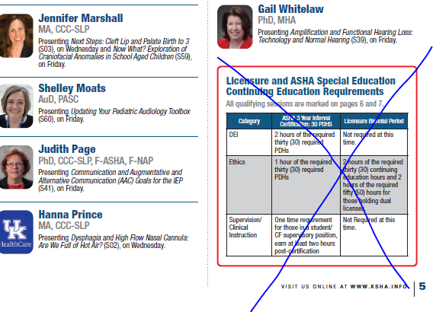
Pages 4-5 Highlighted Presenters
Note: Will need to squeeze – I listed presenters together when co-presenting, hoping to save space. And listed the session info differently this year, again hoping to save space. Don’t include the grid that was displayed last year
Photos: S:\KSHA\Convention - KSHA\2026-Lex-Feb18-20\Speakers-KSHA2026\Photos-KSHA2026

Kellie Banta, MA, EdD, CCC-SLP
(S37) 'Paw'sabilities in Therapy: Utilizing Animals in a Therapy Program

Jen Bidelman, AuD, CCC-A

(S26) Creating a Sensory-Friendly Audiology Visit; (S33) Increasing Cochlear Implant Access in Rural Communities Through Collaboration

Jennifer Blevins, MS, CCC-SLP
Erin Byrd, MS, CCC-SLP
(S61) Tips and Tricks for Navigating MTSS With Confidence

Nick Brock, MS, CCC-SLP
Tina Brock, MA, CCC-SLP
(S30) Supporting Students Holistically: The SLP's Role in Addressing Mental Health

Kelsey Brown, MS, CCC-SLP

(S27) AAC Evaluation for Toddlers and Preschoolers; (S35) Embracing Echolalia: Songs and Scripts for the Speech-Language Pathologist

Elizabeth Burckardt, MD
Lisanne Craven, MS, CCC-SLP
(S29) Surgical and Therapeutic Options for Glottal Incompetence

Trey Cline, PhD, AuD
Kaitlyn Eichen, BS
(S65) Sex Hormones and the Auditory System

Jodi Cottrell, AuD, CCC-A
(S03) Auditory Foundations: Supporting Spoken Language in Deaf and Hard of Hearing Children

Karen Crow, MA, CCC-SLP, MM

(S13) Gender Affirming Voice Care: The Speech Pathologist's Role

Evan Cumpston, MD
Hanna Messmer, AuD, CCC-A
Sara Rogers, AuD, CCC-A
(S33) Increasing Cochlear Implant Access in Rural Communities Through Collaboration

Kelly Curry, MCD, CCC-SLP
Shea Miller, MA, EdD, CCC-SLP
(S63) Coffee Cart in MSD Middle and High Schools

Taylor Denney, MA, EdD, CCC-SLP

(S19) AAC and GLP

Tyler Dorsey, CALC, AAC

(S17) Peeling Back the Onion: Understanding the Emotional Layers of ADHD and Executive Functioning

Rebecca Eberle, MA, CCC-SLP, BC-ANCDS, FACRM

(S45/S50) Social Communication Deficits in Acquired Brain Injury

Kellie Ellis, PhD, CCC-SLP
(S44) Print-Rich Speech Therapy: Linking Letters and Sounds for Success

Jeanane Ferre, PhD, CCC-A
(S42/S48) FAQS (And Answers) About Central Auditory Processing Disorders

Haley Fulk, MA, CCC-SLP

(S28) Born This Way, Became This Way

Laura Galloway, AuD, CCC-A

(S02) Advancing Hearing Screening in Older Adults Through Public Health Initiatives

Amy Gonshak, PhD
(S15) Managing Burnout for Healthcare Professionals

Mary Gospel, PhD, CCC-SLP

Laura Karcher, MA, CCC-SLP, CBIS

(S68) Voices Together: Enhancing Communication and Connection Through Aphasia Support Groups

Jocyline Graham, MA, CCC-SLP
(S14) KEIS to Building Caregiver Rapport in Early Intervention Through Cultural Responsiveness

Lindsey Hendricks, MSSW
Lori Travis, AuD, CCC-A

(S22) Early Hearing Detection and Intervention: Understanding Successes and Needs in Kentucky

Haiping Huang, AuD, CCC-A
(S59) Listening to the Emotions in Sounds - What is Research Telling us and What Does it Mean for our Practice?

Alice Inman, MS, CCC-SLP, BCS-S
(S60) Rethinking the Use of Thickened Liquids: A Call to Action!

Marie Ireland, PhD, CCC-SLP, BRS-CL
(S04) Post-Pandemic Skill Gap and Poverty: Is it Difference or Disorder?; (S20) Catalysts for Change: Tackling 9 Challenges in School-Based SLP Practice

Zachary La Fratta, AuD, CCC-A

(S05) Incorporating Transparency Verification in Remote-Microphone Fittings: From Concept to Clinical Practice

Jennifer Lutes, MS, CCC-SLP

(S41) Dysphagia Management in Head and Neck Cancer: Multi-Modality Approach

Megan Mays, MS, OTR/L
(S51) Talk Sensory to Me … The Relationship Between Sensory & Communication; (S56) First Regulate, Then Communicate - Integrating Sensory Into Speech Therapy for Neurodiverse Pediatric Populations

Laura Mize, MS, CCC-SLP
(S25/S32) 11 Skills Live! Prelinguistic Skills for Toddlers and Preschoolers

Anne Olson, PhD, CCC-A
Ian Windmill, PhD
(S12) Academic Perspectives on Audiology’s Next Chapter

Kathy Panther, MS, CCC-SLP
(S34) Best Practices for Dehydration Prevention and Hydration Balance

Alisa Sacker, MD

(S24) Unlocking Potential: Addressing Oral Ties in Early Childhood

Sara Schneider, MS, CCC-SLP

Jennifer Stanley, MA, CCC-SLP

(S01) AAC in Aphasia Care: Advocacy, Awareness and Therapeutic Impact

Ciera Sherwood, MS, CCC-SLP

(S57) Let's Play! Strategies to Confidently Use Play Therapy Everyday

Kevin Simmons, MS, CCC-SLP

(S46/S52) Therapeutic Harmony: Evidence-Based Music and Sensory Interventions for Speech

Stephanie Spires, MSEd

(S53) What the IEP? What the Team Needs to Know to Help the Parents Understand?

Debra Suiter, PhD, CCC-SLP, BCS-S
(S21) Communicating Results of Videofluoroscopic Swallow Studies

Kelly Vess, MA, CCC-SLP
(S43) Improve Speech Outcomes in Toddlers With Apraxia and Autism; (47) Books to Breakthroughs: Ignite Language Development Through Multisensory Literacy Strategies

Pages 6-7 Session Tracker
S:\KSHA\Convention - KSHA\2026-Lex-Feb18-20\ProgramMailer-KSHA-2026\Tracker-KY2026.xlsx

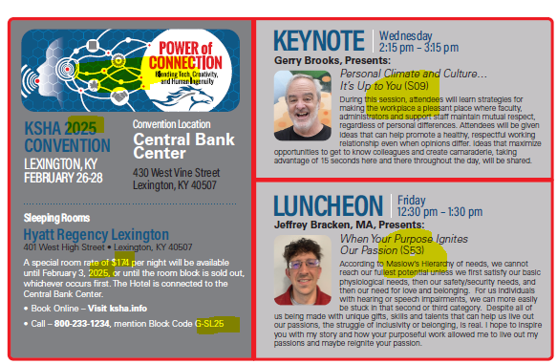
Page 8-Back Cover - Replacement info below.

Left Panel Edit highlighted Items

2026

A special room rate of $179 per night will be available
until February 3, 2026 or until the room block is sold out,
whichever occurs first. The Hotel is connected to the Central Bank Center.
- Book Online – Visit ksha.info
- Call - 800.233.1234 and ask for Code G-SL26

KEYNOTE
Photo: S:\KSHA\Convention - KSHA\2026-Lex-Feb18-20\Speakers-KSHA2026\Photos-KSHA2026\Thompson-Keynote.jpg
Wednesday 2:15 pm – 3:15 pm
Why Not Us: Standing With the People We Serve (S10)
Adria Thompson, MA, CCC-SLP

As communication experts, we work with individuals who often have powerful stories to tell, but their communication challenges can make it difficult to share those stories independently. Advocacy in our field doesn’t have to mean speaking for our clients. Instead, we can remove barriers, create access and amplify their voices. Whether we are helping someone express a simple preference or supporting them in sharing their lived experience on a larger stage, we are uniquely positioned to step in and make it possible. Our clients have something to say and they deserve the chance to say it. So … why not us?

LUNCHEON
Photo: S:\KSHA\Convention - KSHA\2026-Lex-Feb18-20\Speakers-KSHA2026\Photos-KSHA2026\Vrana.jpg
Friday 12:30 pm -1:30 pm
All the Tools in My Toolbox: My Story With Autism (S54)
Catlaina Vrana

This session is about how we can understand, respect and utilize an individual’s unique experience of communication differences and disabilities to help them achieve their best life. Foundational information about autism will be covered, including its definition and characteristics. This information is interspersed with the lived experiences of the autistic presenter. The language and labels used to describe those with developmental disabilities will be discussed: when labels are harmful and when they’re helpful. The session will end on the topic of alternative communication and how we can preserve respect in communicating with people of all abilities.

Registration Insert Page
RegFormEDITS.pdf

