Bill the current information on the website for Past Recipients should stay.
The would like to have photos added to the website of 2013 recipients.

They are listed/shown below, and the actual photos are saved in the folder.

Honors of the Association
Recipient – Joan Bruno, PhD

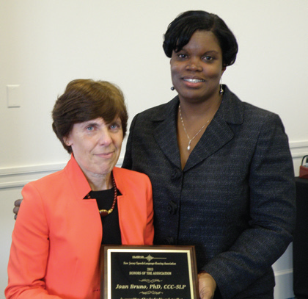
Joan Bruno and Linda Tucker-Simpson

Distinguished Clinical Service Award
Patricia Stuart Shanes, MS

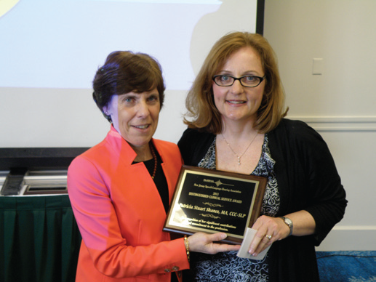
Joan Bruno and Patricia Stuart Shanes

Volunteer of the Year Award
Kelly Pezzanite

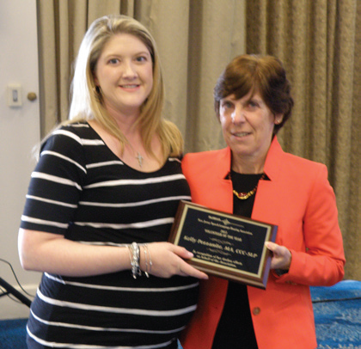
Kelly Pezzanite and Joan Bruno

Program of the Year Award
The Lake Drive Sound Program’s Ivy Nursery

Joan Bruno and Michele Klimovitch

