Proposal for Renovations to NJSHA Website
Model our website after the current Ohio Speech-Language Hearing Association Website http://www.ohioslha.org/
- HOME PAGE (MENU)
  - Keep the same number of “tabs”.
  - Change “licensure” tab to “credentials
  - Change “grants and awards” to “awards” (use PSHA design and font for listing awards along with our forms)
  - Keep “search box” at top
  - Keep link to “home” across
  - Would like a more prominent “contact us” link. There is one at top of page
  - Facebook links should be more similar to what is on existing NJSHA page
  - We prefer the scrolling “box” on our current NJSHA page to the scrolling textline on Ohio’s page.
  - Would like to use a similar “welcome message”
  - Use New Jersey instead of “stock” photos. Change photos on a regular basis. (by utilizing ever-changing photos of NJSHA members more people will go on the website to see if their picture is on it. Do we need photo releases to use pictures?)
  - Have QUICK LINKS like these, with “Today’s Buzz” going to current news and announcements
  - “Practice Areas” –- on Ohio’s site, these are hotlinks that go to webpages about the committees. I like the idea of having links on the home page that go to committees, but call it “NJSHA Committee Updates” instead of “Practice Areas”
  - Paid ads---note how they are paced in different areas across the website pages-good idea.
  - Add a members log-in button above the tabs on the home screen that goes to the “members only” documents (i.e. Newsletter, legislative and school affairs documents) This could serve as the “member center” we currently have
  - For links to any specific documents that are under any drop down tab that are restricted for members, have listed “login” next to them (maybe)

- ABOUT TAB (MENU)
  - Change tab About name to “About NJSHA”
  - Drop down menus containing:
    - Mission Statement
    - Strategic Plan
    - Bylaws
    - Code of Ethics
    - Governance—with a Link to Executive Council—Board of Directors—Committee Chairs (Committee Chairs should link to the committee pages)
    - Who Do We Represent
    - Board and EC Link-we do not want this to look exclusive- here could be the locked are for board financial policies, board meeting minutes and documents, committee reports
    - Contact Us
- Some drop down tabs may have multiple level of tabs within
- Color code tabs based on which ones are for members only and those that are open to the public (maybe)

- MEMBERSHIP TAB (MENU)
  - Items under membership tab should include:
    - Benefits (Change name to “member benefits”)
    - Membership
    - Join or Renew your membership
    - Learn about committee membership
- Quick link on home screen to the Membership Application ???

- LICENSURE/CREDENTIALS TAB (MENU)
  - Drop down tabs to include:
    - NJ Licensure (with links to the licensure website and application)
    - . NJ DOE
    - ASHA (with links to information on obtaining certification, evidence-based practice) (also keep tabs Ohio has to docs on ASHA website-add code of ethics here as well and scope of practice in speech-language pathology ASHA doc)
    - AAA (similar to Ohio’s format)

- EDUCATION TAB (MENU)
- Change the name to “Continuing Education” versus “Education”
- Menu Items on dropdown to be the Same as Ohio, plus add “Webinars”
- Calendar of Events would include all NJSHA and NJSHA co-sponsored CE activities
- Potentially add links to other entities PD events in exchange for us advertising our events on their website
- Add a tab called “Photo Gallery” here for pictures of all NJSHA events

- RESOURCES TAB (MENU)
  - Tabs under this dropdown menu to include:
    - Professionals
      - Member Benefits brochure (being developed).Here is the
link to Ohio’s: (NN)(JB)http://www.ohioslha.org/pdf/NewProfessional/KeyReasonsNewProfessional.pdf
      - Job Postings (or links)
      - Add tab called “Career Center” or “Job opportunities” when get Job Target up and running
      - Keep much of the same information/links that are on NJSHA’s current “member center” with links from these items (e.g. SAC, Legislative, Healthcare) to relevant FAQ sheets that are for member log-in only-maybe have a member center tab with viewable sub-tabs links to see what information is available if you are a member.

        - Update/Edit your account information
        - Renew Your Membership
        - Search for a Member
        - Printable Membership Directory
        - Read VOICE
        - School Affairs Resources
        - Legislative Affairs Resources
        - Healthcare Updates

    - Students
      - Committee Opportunities
      - Research Support (access to member e-mail list for surveys)
      - Link to Student Poster submission for convention (we want to move to an online format for this for 2014)
      - The Marni Reisberg memorial Award
      - Link to NSSLHA page
      - Student Benefit summary Page (or pdf of flyer under development)
      - Maybe add a tab for university NSSLHA initiatives listing the activities of each university’s local NSSLHA chapter
      - Add Career Center when get Job Target up and running List FAQ’s (the ones we currently have on our site that are being revised about our profession in general and our areas of practice-Add this under “consumer resources” as well

    - Consumers
- We have good content now on NJSHA page, but it need to be more accessible. This tab should include links to the following which then lead to appropriate lists of content : https://www.njsha.org/resource/
      - About the Professions
      - Audiologists
      - Speech Language Pathologist Speech, Language & Hearing Scientists
      - Career Questions
      - Studying to Become a Professional in New Jersey
      - Aphasia
      - Assistive Listening Devices
      - Augmentative and Alternative Communication
      - Finding a Certified Audiologist or Self-help Group
      - Noise and Hearing Loss
      - Tinnitus (Head Noise)
      - Otitis Media
      - Voice Problems
      - Stuttering
      - Articulation
      - Child Language
      - Licensing DELETE from this area
      - Protecting Speech, Language and Hearing
https://www.njsha.org/resource/consumer.html
**Sub-tab: For Parents, Caregivers, and healthcare providers with links to Healthcare and Helpful Documents
The New Jersey Speech-Language-Hearing Association recommends that parents, caregivers and healthcare providers will use this Resource Center to obtain useful information about speech, language and hearing disorders.
a) Healthcare Documents
Insurance Advocacy-Handling Claims and Denials
New Law to Provide Speech Therapy and Other Services in NJ
b) Helpful Documents
Better Speech and Hearing Month Door Hangers
Better Speech and Hearing Month Bookmarks
How Speech-Language Specialists Help Children Improve Literacy
How Audiologists Help Children Communicate Better
How Speech-Language Specialists Help Children Communicate Better & Succeed in School
Protecting Speech, Language & Hearing
Advances in Speech
Advances in Hearing
https://www.njsha.org/resource/media.html (update content a little)
Delete NJSHA Code of Ethics

***Sub tab: Public Service Announcements (this came from:
https://www.njsha.org/resource/consumer.html

Better Hearing & Speech Month
Summer Literacy
FAQ
Links
    - Board of Directors Resources
      - Fiscal Policies
      - P&P
      - Board Contact Phone #
      - Committee Contact Phone
      - Board Meeting Dates
      - Board Minutes
      - Committee Report Form

    - Media Resources
      - links to videos
      - PSA’s
      - Newspaper or magazine articles
      - Media kit
      - Current links to organizations

- ***Have a hierarchy of sub tabs with links for each category of resources listed above****
- Add a link from various menu items (e.g. professionals) to a page that shows hot links to all available resources. Some of the items would be accessible to all e.g. on the NJSHA website, there is now a “free” link to a pdf brochure on How SLPs can help children succeed in schools: https://www.njsha.org/members/documents/School-final.pdf
- Links to SAC documents to be marked members only (e.g. Medicaid Memo). We want people to see the types of information that is available to members.
- Website should list all available documents, but restricts which ones can be opened.

- ADVOCACY TAB
  - Include “Legislative Alerts” (list on scrolling feed as well)
  - Awards should go under “awards” tab-not advocacy
  - Advocacy “Tool Kits” that include items such as the power point from the NJSHA Convention session on advocacy.
  - Links to items related to advocacy that are also referenced under the Resources tab (e.g. Insurance Advocacy).
  - Student Advocacy Program (we have materials from Day in Trenton but they are not on web yet. Also, we hope to make those an annual event.)
  - . Link to NJSHA PAC page (better organize this)
  - Legislative FAQs?
  - Menu items linking to:
    - US Congress page-where members can log in and find their congressional members (egg: http://www.house.gov/representatives/find/)
    - . NJ Legislature page where members can find their state legislators (e.g. http://www.njleg.state.nj.us/members/legsearch.asp)

- GRANTS & AWARDS TAB
  - Change tab name to “Awards”
  - Include description of currently offered NJSHA awards (Marni Reisberg and others at the Convention)
  - List of past recipients for each award
  - Procedures for nominating individuals/agencies for awards

- PUBLICATIONS TAB
  - Links to VOICES: Current Issue; Archived Issues; Editorial Board; How to Submit an article. This should be member benefit and locked
  - Link to Journal if we decide to do one.
  - Link to Facebook pages
  - Ohio has website here. Include information for advertisers, agencies that want to link from our page, etc.

***Have links to facebook page, facebook group and twitter on the homescreen as well
- QUICK LINKS (HOMESCREEN)
  - Similar to the ones on Ohio’s website: (i.e. “Today’s Buzz” goes to current news and announcements.
  - Hot links to include:
    - Member Benefits
    - Join/Renew Membership (with a link to the membership application or have as its own separate link
    - NJSHA Convention
    - Today’s Buzz
    - Videos
    - Member Center (only if we do not add a “login” button on the top of the homescreen)
**Have the Contact US button with a link to our contact information similar to Ohio’s page, but add Facebook and Twitter Links, add NJSHA new logo and a photo
***We like the consistent flow of page organization OHIO has with links to documents on left hand bar once you open each tab
***We propose to link content across dropdown menu tabs like we currently have on the NJSHA site, so you can find information in multiple places. Ohio has this with various links on the side bar of each page with duplication of related material from other parts of the website

HOMESCREEN

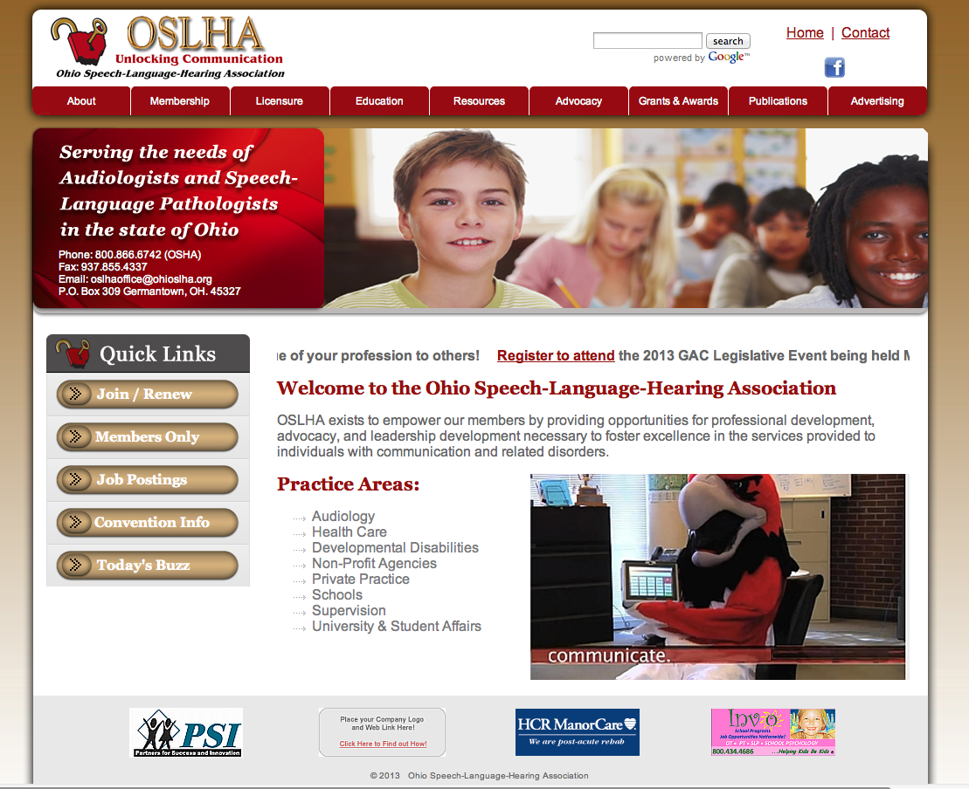
WEBPAGE TEMPLATE
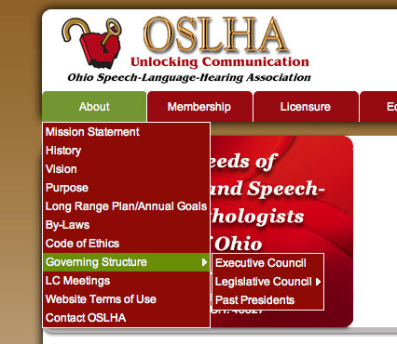
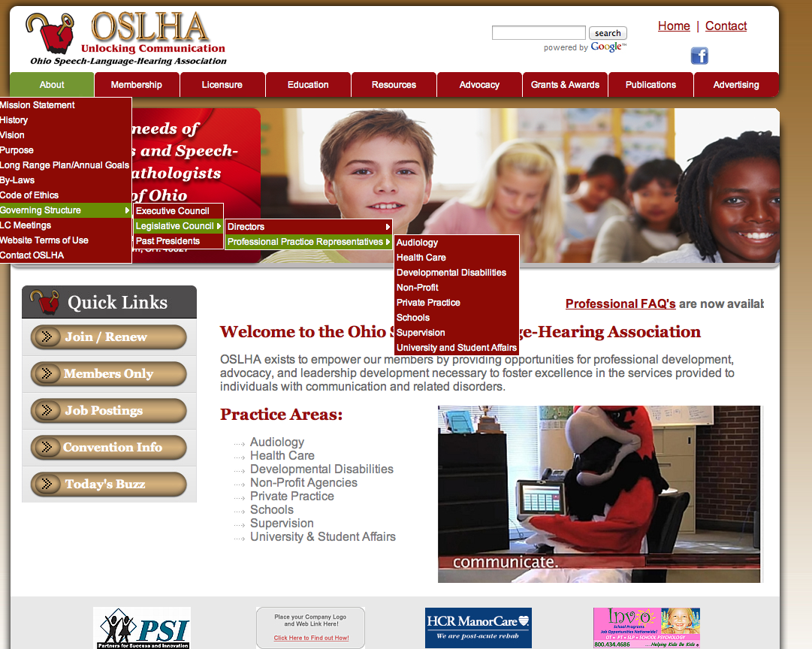

ABOUT US

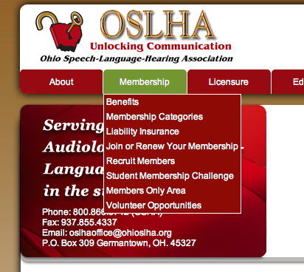
MEMBERSHIP
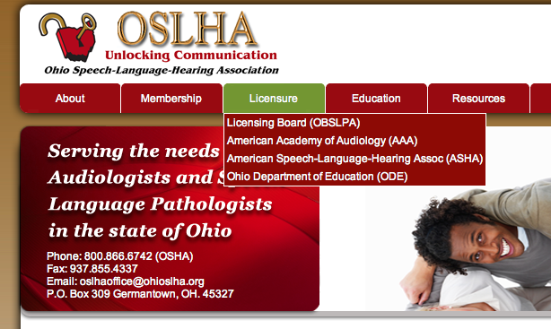
LICENSURE
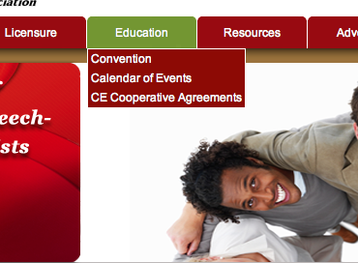
EDUCATION
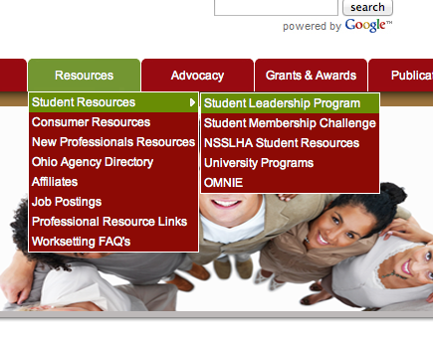
RESOURCES
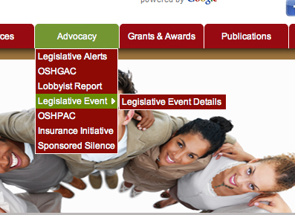
ADVOCACY
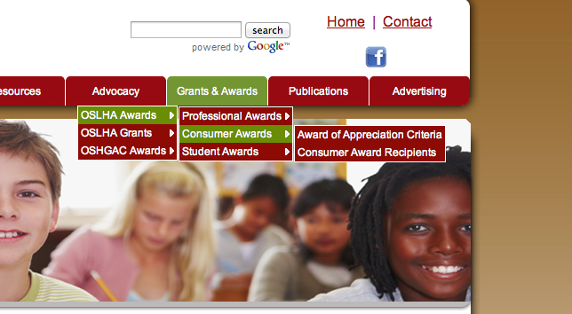
ADVOCACY
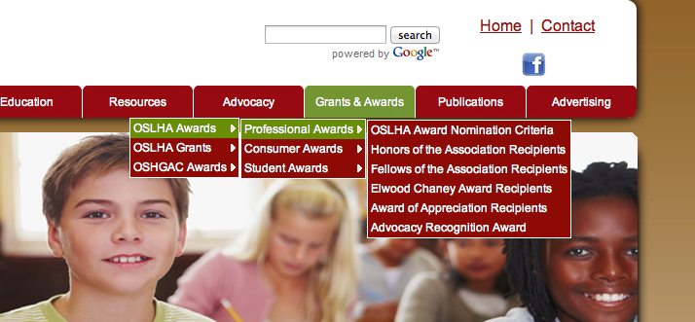
AWARDS
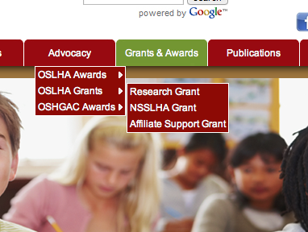
AWARDS
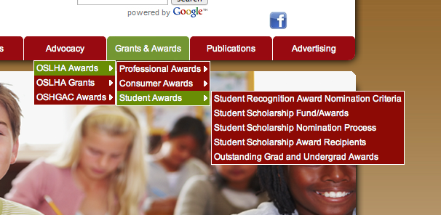
AWARDS
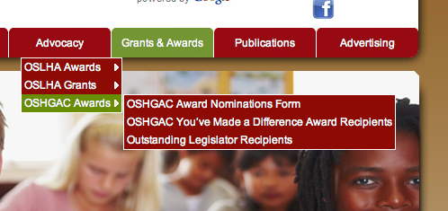
AWARDS
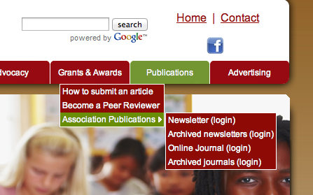
PUBLICATIONS

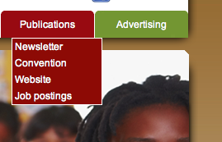
PUBLICATIONS
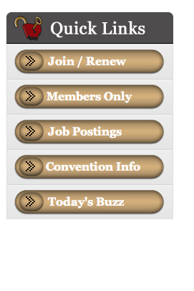
QUICK LINKS
QUICK LINKS
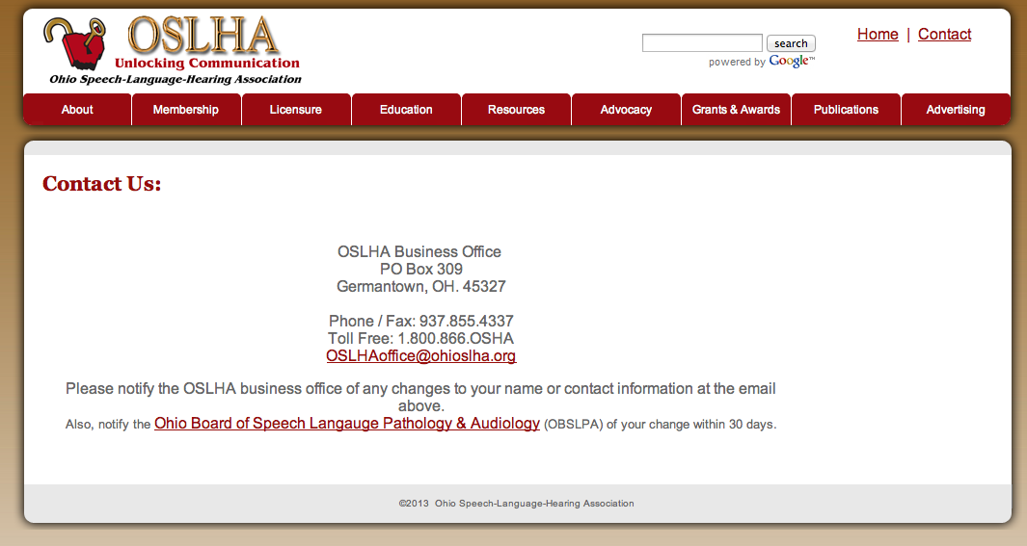
CONTACT US

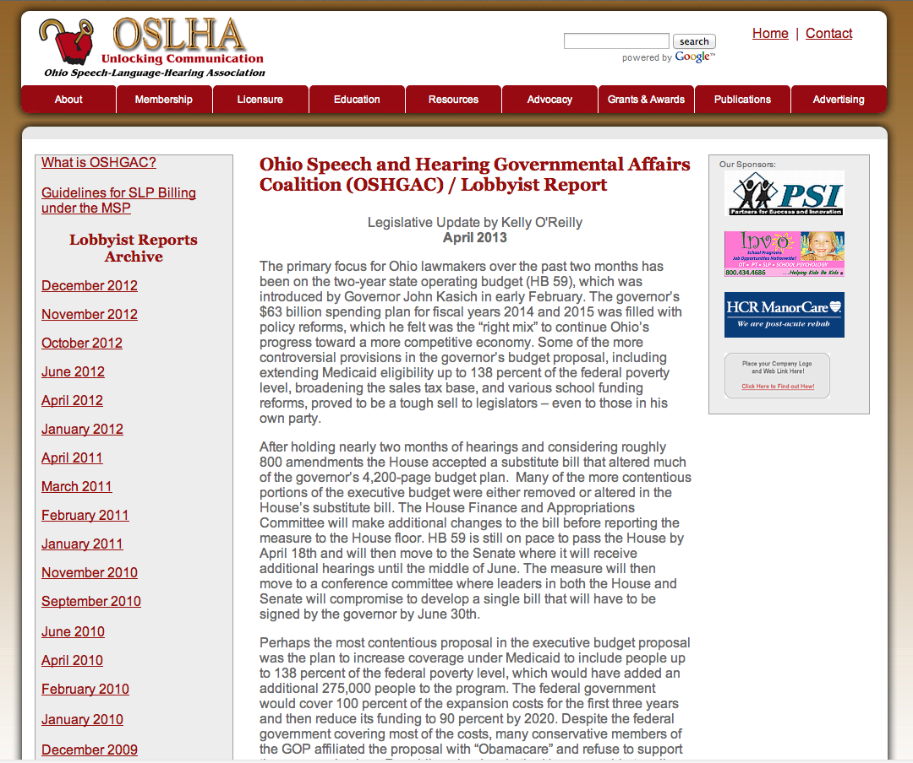
CONSISTENT FLOW OF PAGE ORGANIZATION

